# A:\CBHE-factori\aa-starter\Factori_soumis\communication\logo\Logo Factori 4.0.png

# From Automation and Control Training to the Overall Roll-Out of Industry 4.0 Across South-East Asian Nations

# (ASEAN FACTORI 4.0)

**PROJECT No. 609854-EPP-1-2019-1-FR-EPPKA2-CBHE-JP**

**Round Table: ECTI ICA-SYMP 2023 (2023 Third International Symposium on Instrumentation, Control, Artificial Intelligence, and Robotics) on January 18-20, 2023**

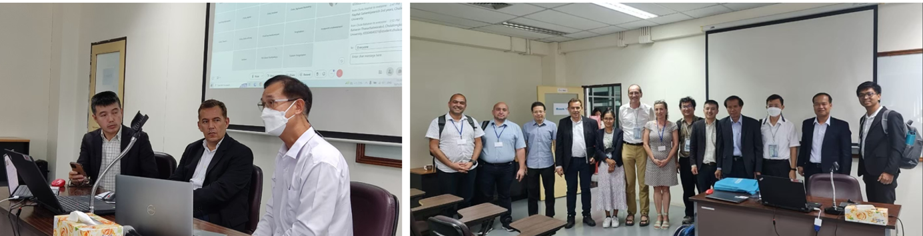

**With the consortium partners, we welcomed Thailand Industrial Standard's representative, Puttipong Kongcharoen; Pattana Sittisombat of the Chiang Rai Chamber of Commerce; and Joseph Pattandilok representing Yokogawa-Thailand.**

ECTI (Electrical Engineering/Electronics, Computer, Communications, and Information Technology Association) is a crucial organization representing teachers and researchers from countries in region 6 including members of ASEAN nations. One of the meeting's key goals is to establish an industrial automation network of competencies among partner countries and extend opportunities to institutions in remote regions that are currently not involved. This approach aims to enable these institutions to benefit from the project's outcomes.

We believe that through this collaboration, we can collectively drive progress in the fields of electrical engineering, electronics, computer, communications, and information technology, benefiting the ASEAN region and beyond. We also plan to share the project's outcomes in various Asian conferences. By doing so, we hope to inspire teachers attending these conferences to adopt the proposed implementation for their respective institutions.

Chulalongkorn University and Mae Fah Luang University joined hands to co-host a roundtable dialogue focused on the project's implications for Thailand's Industry 4.0 initiative. Distinguished attendees encompassed delegates from the Factori Erasmus+ project, Professor Hamed Yahoui; Thailand Industrial Standard's representative, Puttipong Kongcharoen; Pattana Sittisombat of the Chiang Rai Chamber of Commerce; and Joseph Pattandilok representing Yokogawa-Thailand.

Our primary objective is to identify local companies within the domain to engage in discussions about the new educated student profile. Through these interactions, we aim to understand their specific needs concerning lifelong learning programs. The purpose of the external roundtable was to gather insights from industries regarding the types of graduates they required in the Industry 4.0 workforce. Several external delegates representing different organizations shared their insights on the program involving PLC and the impact of Industry 4.0 in Thailand.

In partnership with the University of Ruse "Angel Kanchev," Chulalongkorn University co-authored a research paper that was presented at the ICA-SYMP 2023 conference. The paper, titled "Becoming CU-Asean Factori 4.0 Training Center for Programmable Logic Controller," was authored by Singcuna, S., Kittisupakorn, P., Banjerdpongchai, D., Dawkrajai, J., Daskalov, P., Georgieva, T., Zahariev, P., Bencheva, N., and Yahoui, H. The conference took place from January 18 to 20, 2023, organized by ECTI and ICA-SYMP 2023.

Additionally, Chulalongkorn University in collaboration with the University of Ruse "Angel Kanchev," showcased another paper titled "Implementing PID Control on PLC Benchmark to Enhance Industrial Automation Skills Towards ASEAN FACTORI 4.0." The authors of the paper were Singcuna, S., Kittisupakorn, P., Banjerdpongchai, D., Dawkrajai, J., Daskalov, P., and Georgieva, T. This paper was presented at the ECTI and NCON 2023 conference held from March 17 to 22, 2023.